This is a simple introduction about how to use Amazon Simple Storage Service (S3)

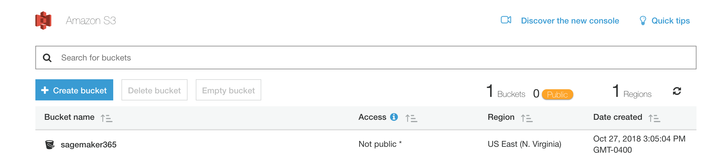

1: Create a Bucket

2: Upload an Object to the Bucket

3: Make Your Object Public

4: Create a Bucket Policy. One can manage rights of accessing the objects.

5: Explore Versioning, S3 stores history version of the object and you can go back at any time.

Time spent: 30 min